**Power BI Lab  
  
Part 1: Access the service and upload data**

This part will be import datasouce (as .xlsx file) to the Power BI Desktop

1. Download Excel file name “Financial Sample – cleansing.xlsx” to your PC/Mac
2. Download Power BI Desktop from <https://www.microsoft.com/en-us/download/details.aspx?id=58494> and choose only version of x64
3. Then install .exe and follow the wizard until finished   
   (Power BI version is monthly update)  
     
   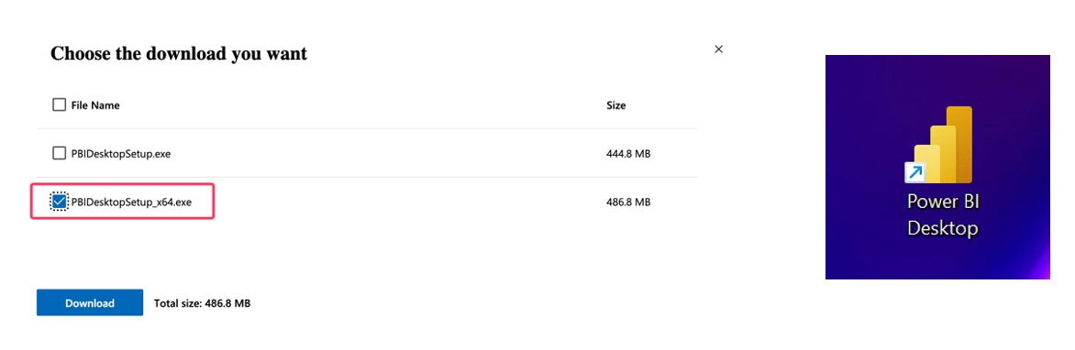
4. Then open Power BI Desktop and sign in with lab user credential. You will see your username at the top right

  
  
*** If you encounter “stay sign in” screen. Please follow the pic below  
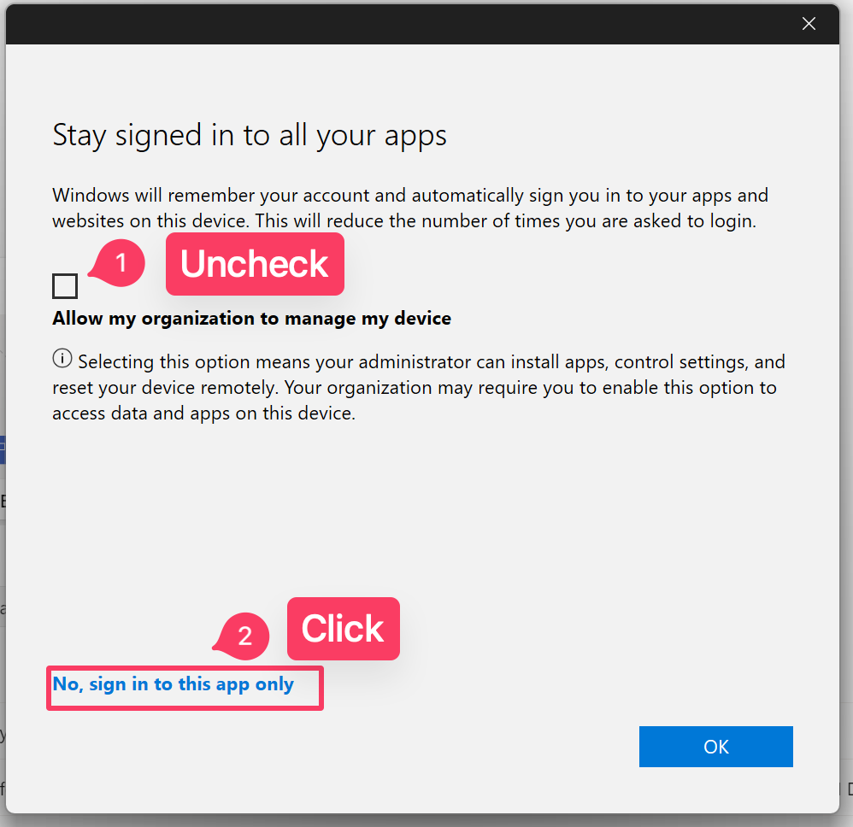

1. Click New report  
   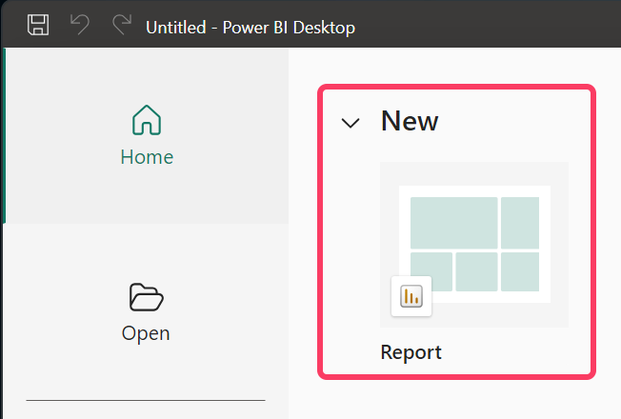
2. Click “Get data”-> “Excel workbook”.   
   At “Upload file” tab upload “Financial Sample – cleansing.xlsx”

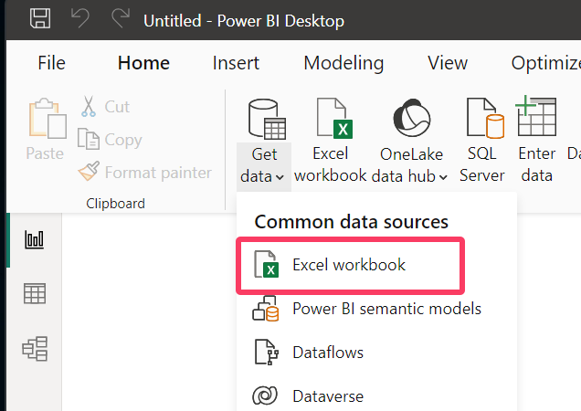

1. Check mark to select only first 3 tables (not worksheet) – financials, ProductTable and Reseller1 then click “Transform data”  
     
   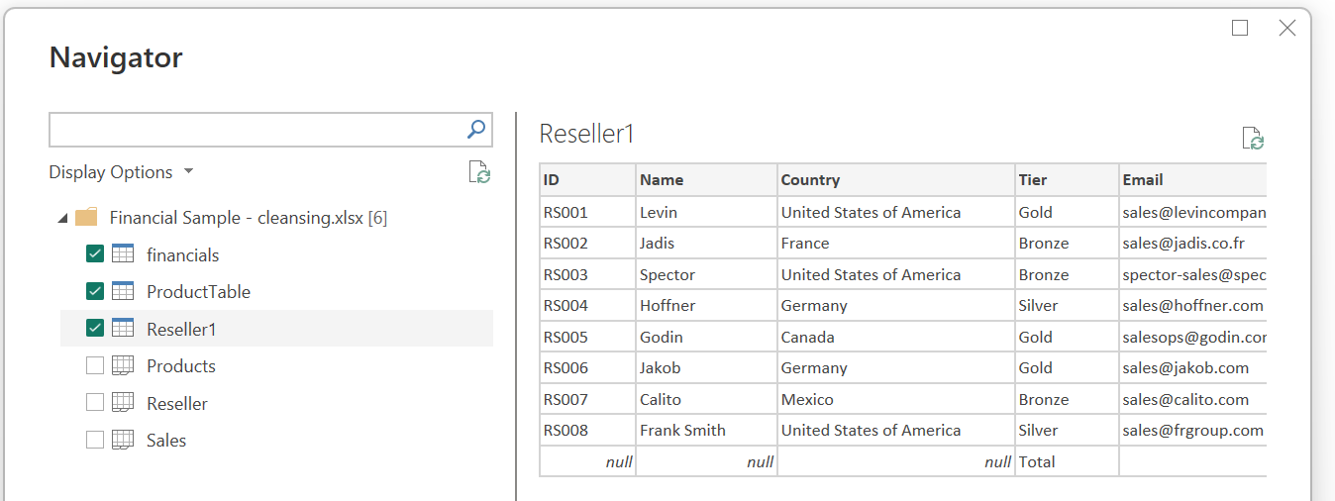  
   A close up of a box

   Description automatically generated
2. Wait for Power Query experience to show up

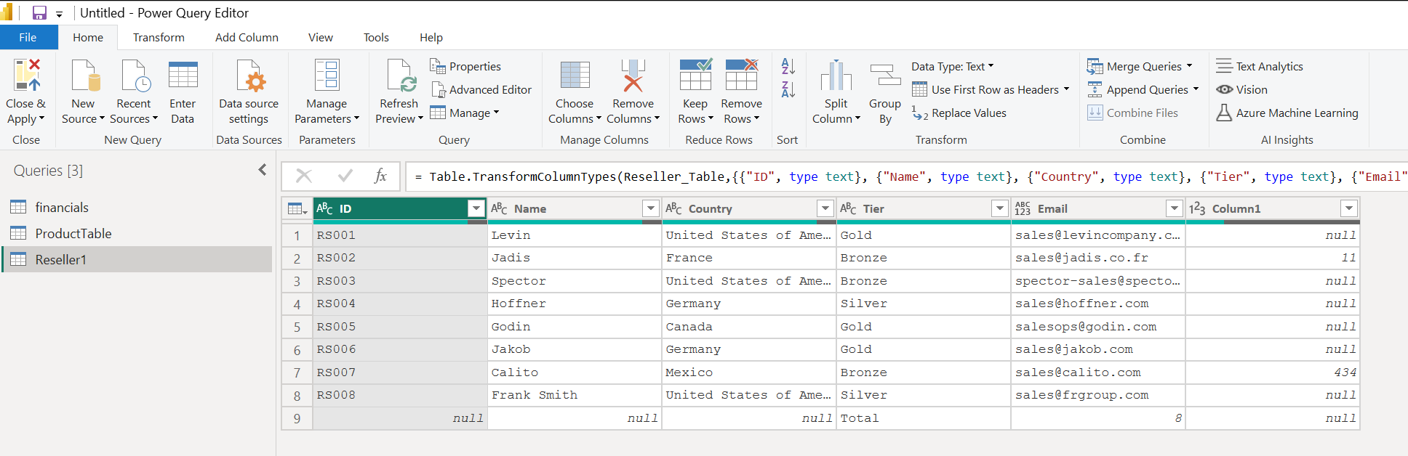

**Part 2: Perform Basic data transformation (cleaning) using Power Query**

Unfortunately, table still not ready to load as semantic model for Power BI report. We need to do some cleansing data inside Dataflow tool (Power Query)

**Rename Tables**

1. At financials table, right click to rename the table name as “Orders”
2. At ProductTable table, right click to rename the table name as “Products”
3. At Resellers1 table, right click to rename the table name as plain “Resellers”

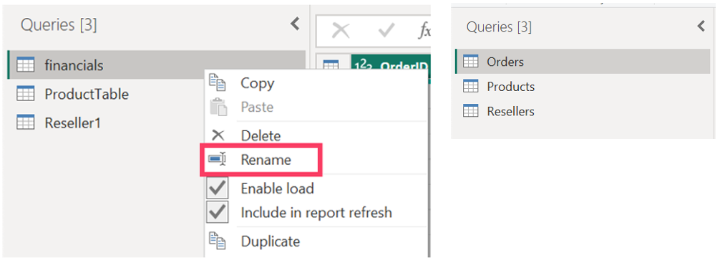

**Replace null value**

1. At Orders table, right click at Discounts column and choose “Relace value”.   
     
   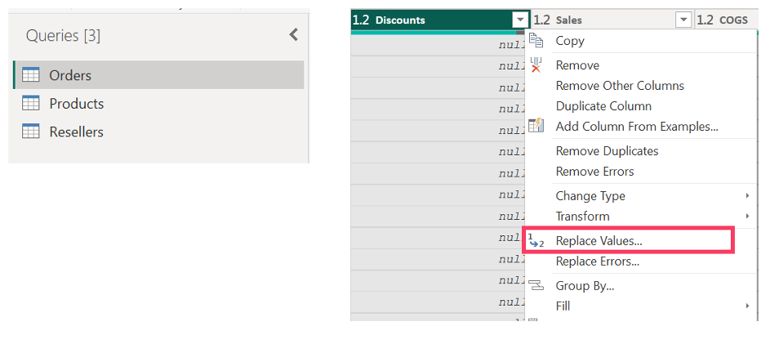  
     
     
   Then input “null” at Value to find and input 0 at Replace with (replace null value with 0)  
     
   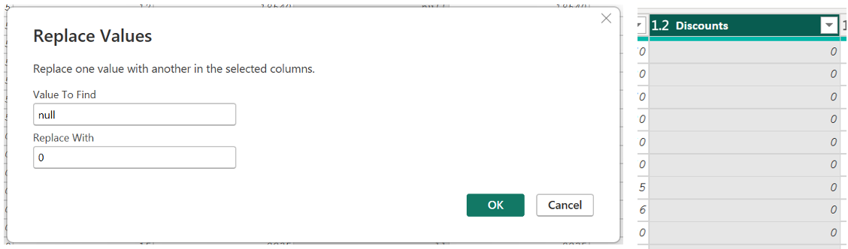

**Remove any unused rows and columns**

1. At Resellers table, right click at Column1 and select Remove columns  
     
   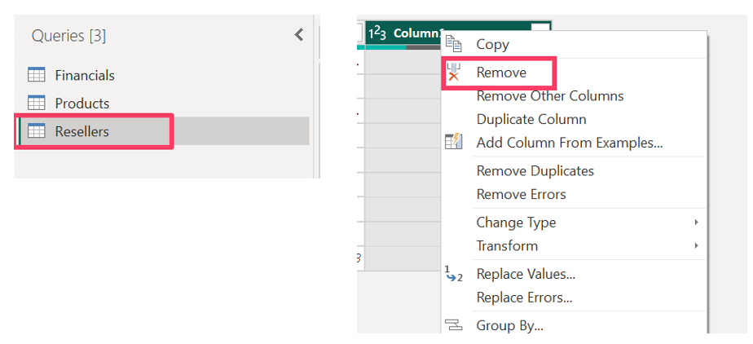
2. Then at “Home” tab, click “Remove rows” -> “Remove bottom rows” and input 1 for last row removal  
     
   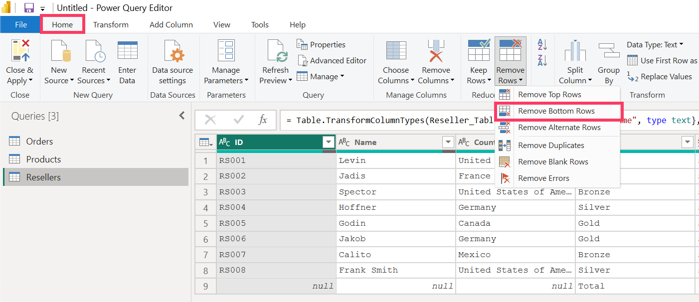  
     
   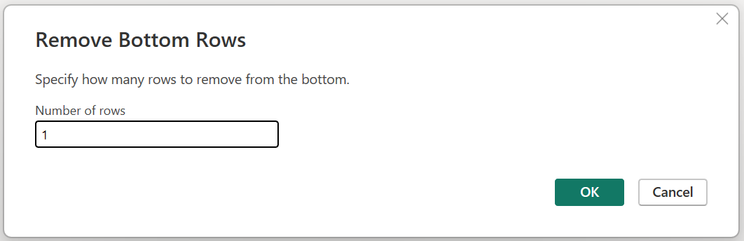
3. Then click “Close & Apply” and wait until data is loaded to Power BI Desktop  
   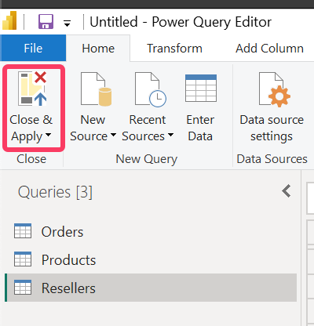

**Part 3: Data Model preparation**

Date and time-based analyses are usually required in Power BI reports. This is where making a date table comes in handy. Date tables allow you to slice and dice your data by date attributes such as weekday, month, quarter, and year. Also, relationship among tables need to be set. If Power BI generates auto-relationship for us, it still needs to be validated  **Create Date table using DAX**

1. Click on “Data view” and select “New table” at Table tools tab  
     
   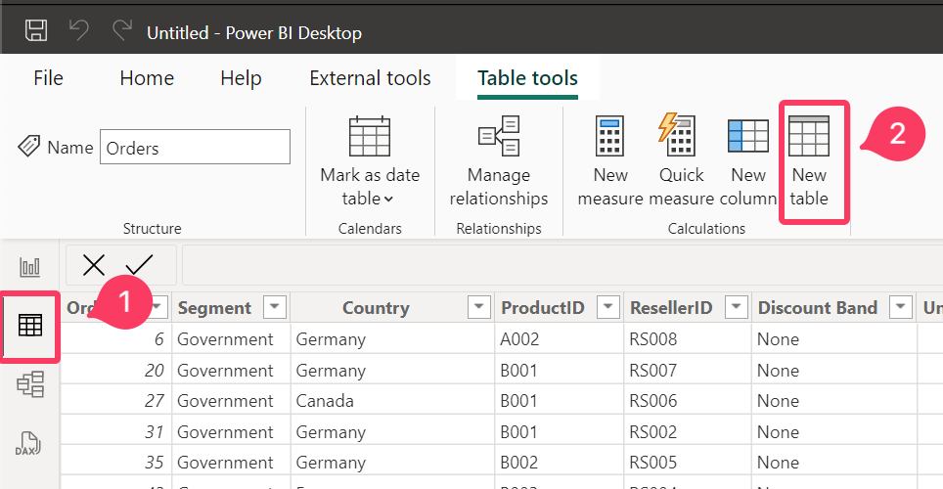
2. Replay with DAX calculation below and hit enter for Date table creation  
     
   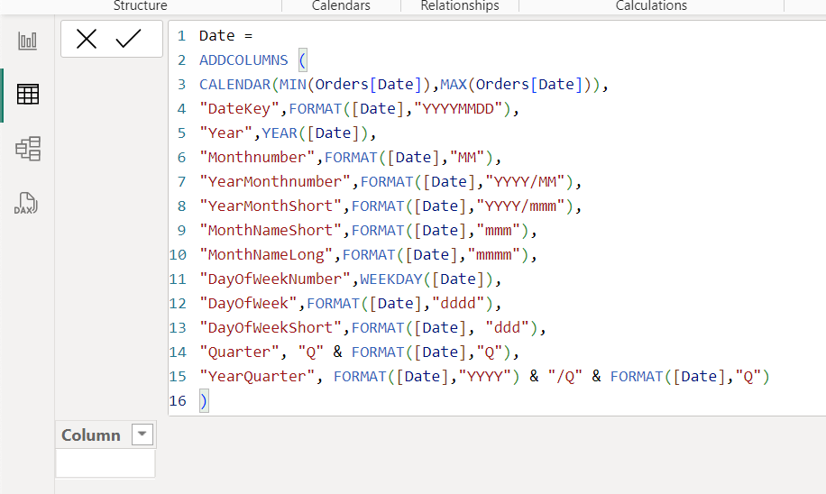

Date =

ADDCOLUMNS (

CALENDAR(MIN(Orders[Date]),MAX(Orders[Date])),   
"DateKey",FORMAT([Date],"YYYYMMDD"),

"Year",YEAR([Date]),

"Monthnumber",FORMAT([Date],"MM"),

"YearMonthnumber",FORMAT([Date],"YYYY/MM"),

"YearMonthShort",FORMAT([Date],"YYYY/mmm"),

"MonthNameShort",FORMAT([Date],"mmm"),

"MonthNameLong",FORMAT([Date],"mmmm"),

"DayOfWeekNumber",WEEKDAY([Date]),

"DayOfWeek",FORMAT([Date],"dddd"),

"DayOfWeekShort",FORMAT([Date], "ddd"),

"Quarter", "Q" & FORMAT([Date],"Q"),

"YearQuarter", FORMAT([Date],"YYYY") & "/Q" & FORMAT([Date],"Q")

)

1. You will see new table called “Date” at the right  
     
   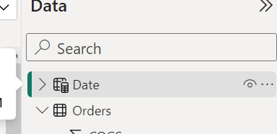
2. Then right click and select “mark as date table”  
     
   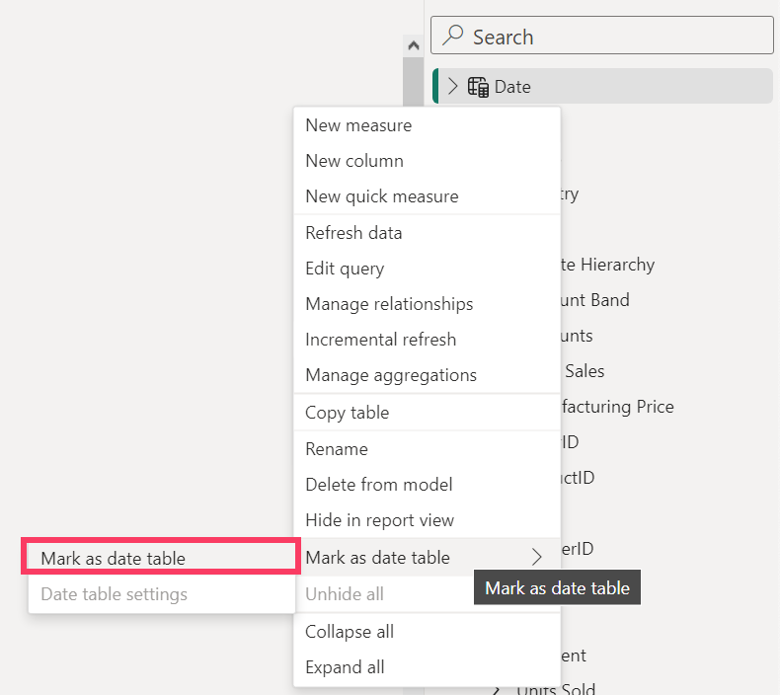  
     
   *** Optional, you can disable “auto create date table” for decrease the date size at Files. -> Option and settings -> Options. At Global -> Data Load go to Time intelligence and uncheck Auto date/time for new files. Then close and restart Power BI app
3. Then click MonthNameShort column. At Column tools, sort the MonthNameShort column to MonthNumber. You can do for MonthNameLong as well.  
     
   ** You can go ahead to sort things like DayOfWeekShort, YearMonthnumber etc. to the related sort column  
     
   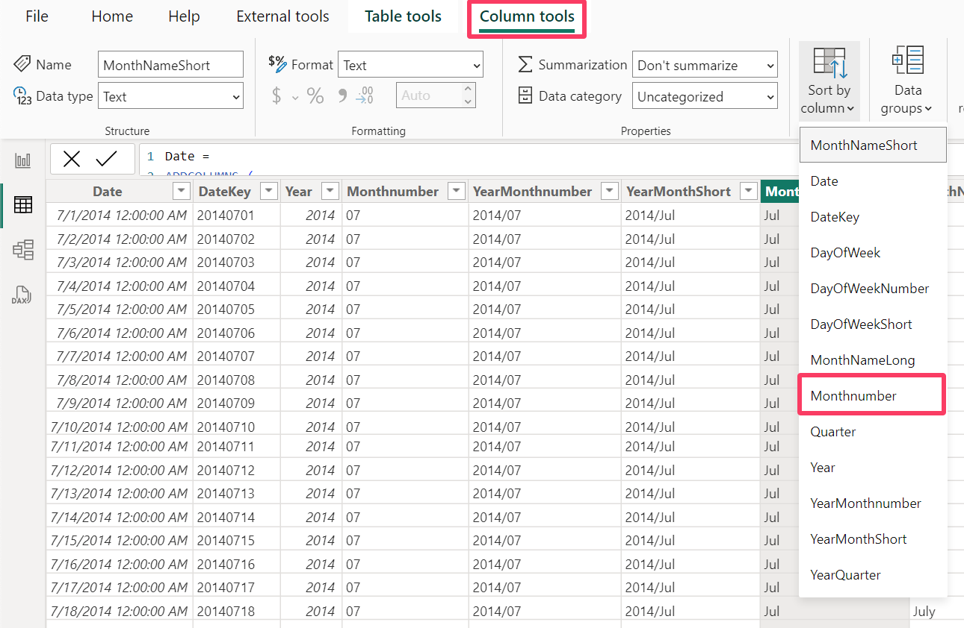

**Relationship model**

1. Click on “model view”  
     
   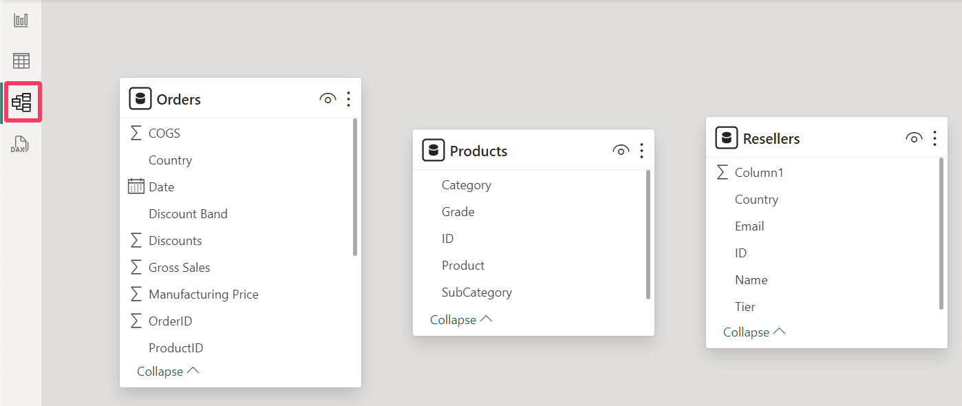
2. Drag ProductID of Orders table to ID of Products table. Then set Cross filter direction to “Both” and click “Apply changes”   
     
   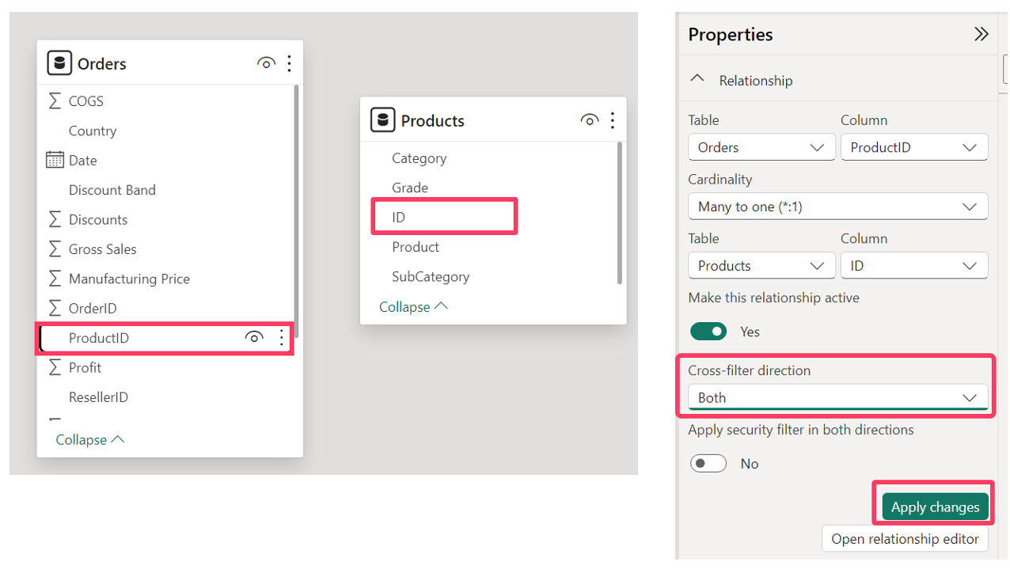
3. Drag ResellerID of Orders table to ID of Resellers table. Then set Cross filter direction to “Both” and click “Apply changes”   
     
   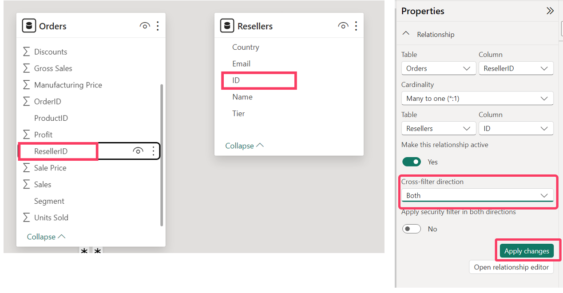

1. Drag ResellerID of Orders table to ID of Resellers table. But leave the cross-filter to “Single”

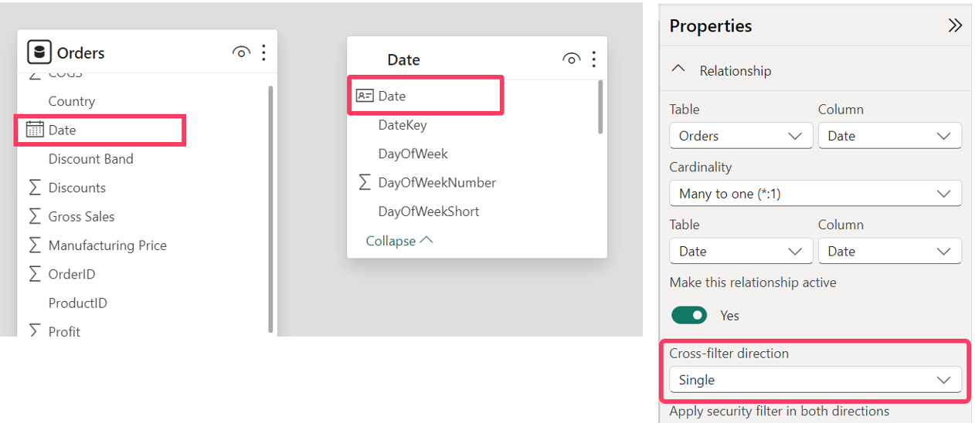

**Part 4: Making reports**

Now the semantic model is ready for report creation. We are exploring some basic visualization creation. Feel free to explore things more than this lab provided

1. Click on “Report view”   
     
   A screenshot of a computer

   Description automatically generated
2. Click Card, Drag Sales column from Orders table to Fields. You can change font, size, color and units (billion, thousand). You can add the title text too  
     
   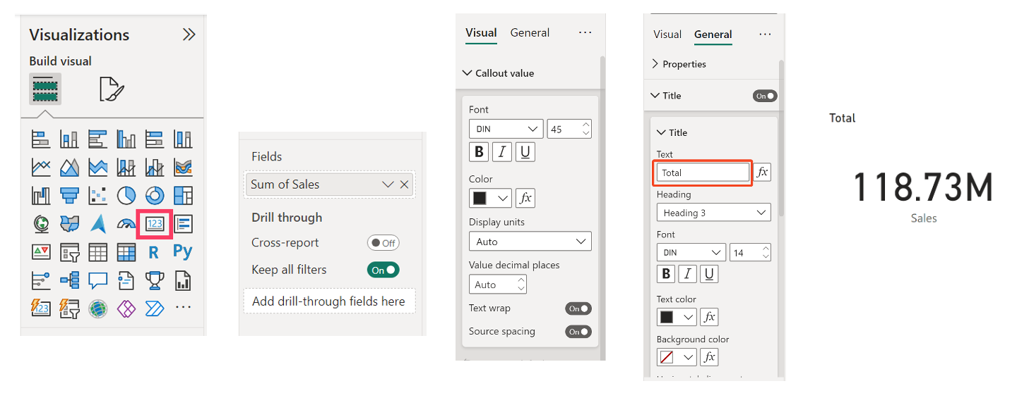

1. Click Pie, Drag Segment column from Orders to Legend, Drag Sales column from Orders to Values  
     
   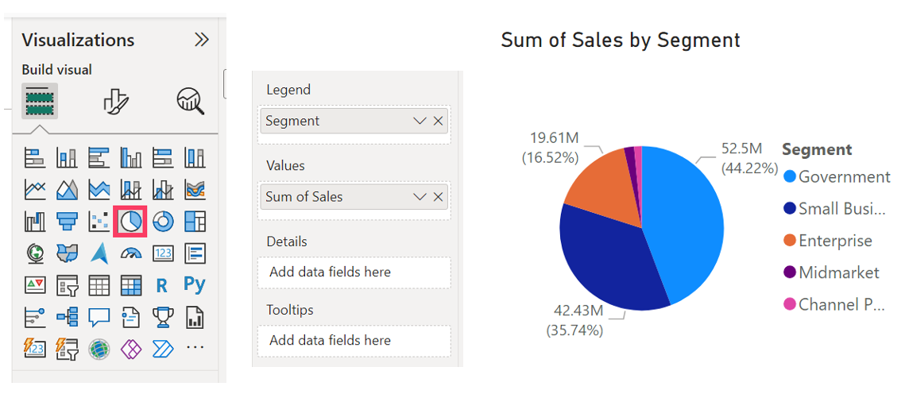
2. Create Table visual and drag Name and Tier column from Resellers tables into field, and then drag Sales and Unit Sold Column from Order table to the same field too. You can double click to rename “Name” to be as “Reseller Name”  
     
   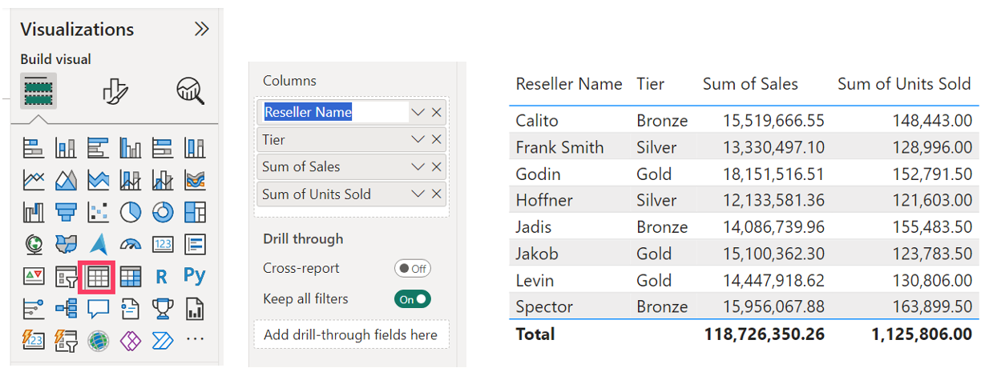  
     
   Then make a new table of Country Sales and Unit Sold column of Orders table

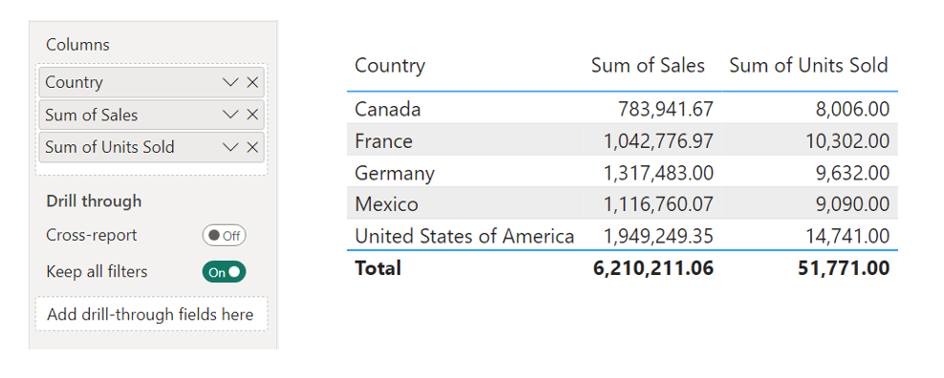

1. Select Line and Stacked columb chart, drag MonthNameShort of Date to X-axis, Sales of Orders to Column y-axis, Profit of Orders to Line y-axis and Grade of Products table to Column Legend. Lastly click … to sort the graph to a correct month order

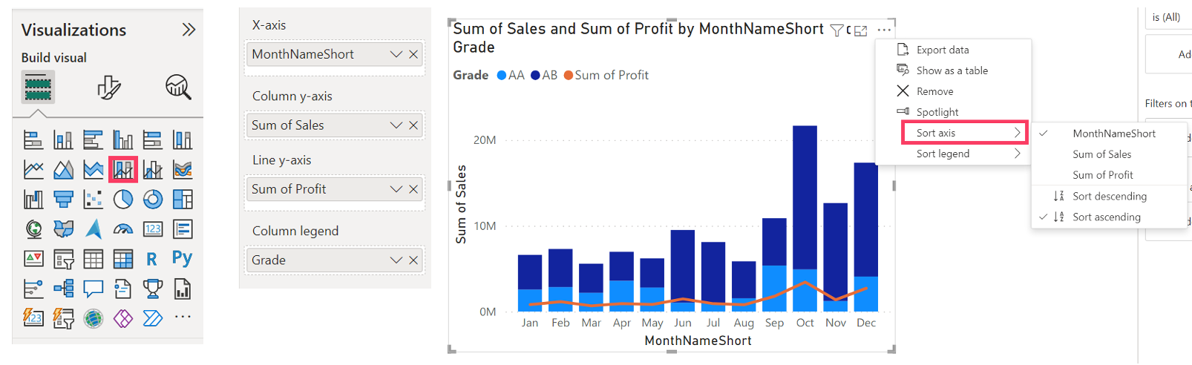

1. Select Slicer, Drag Year column of Date table. Then adjust type to be as dropdown like the pic below. Now you can see sales and unit sold by each year and each month by Segment, Country, Resellers and Product grade  
     
   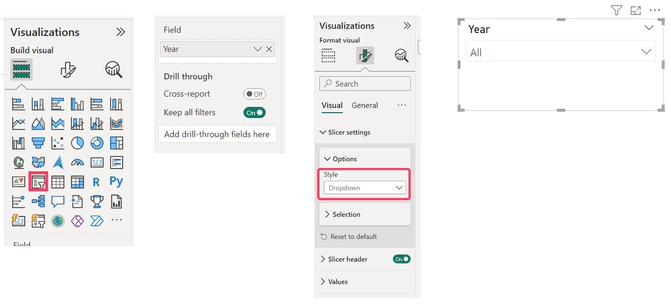
2. Right click at Orders table and choose “New measure” then input this DAX formula below and press enter. You will see DAX measure name “LY Sales” in Order table

LY Sales = CALCULATE(SUM(Orders[Sales]), SAMEPERIODLASTYEAR('Date'[Date]))  
  
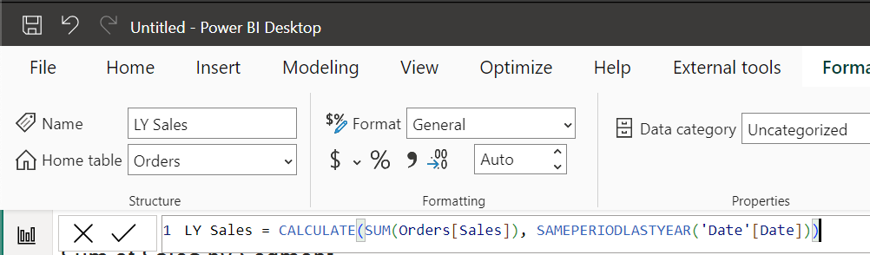

1. Create another card visual and drag “LY Sales” measure to the field. The result will show the previous year total sales of year 2013 when you select the slicer to year 2014  
     
   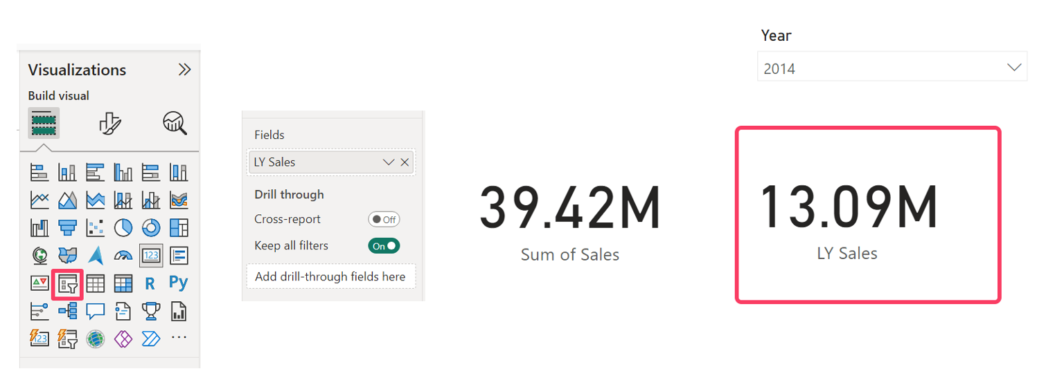

**Part 5: Save and Publish to the cloud (Power BI Service)**

Now the report visual, model and DAX calculation are ready in this semantic model. Then we publish the data to the cloud at “My workspace” to yourself to consume via web or mobile from anyplace or others users in “Shared workspace”.

1. Click File -> Save as the file and name the report as “Lab1”.

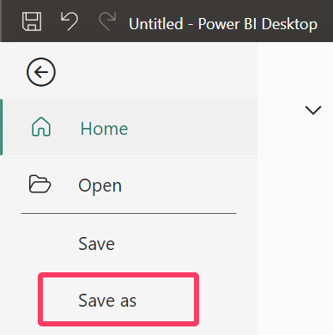

1. At Home tab, click Publish button and Select “My workspace”  
     
   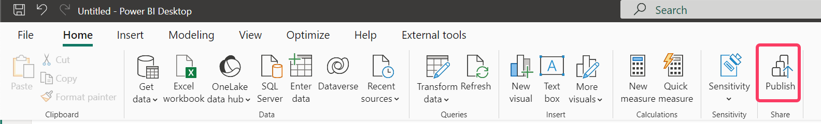

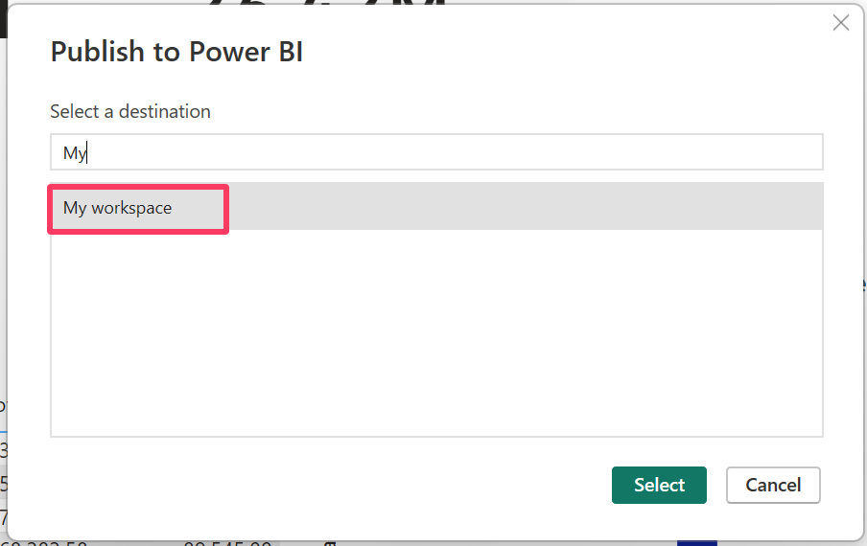

1. Finally, head to the link (it will you redirect to <https://app.powerbi.com/groups/me/list?experience=power-bi>) to see your online report  
     
   